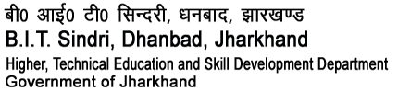

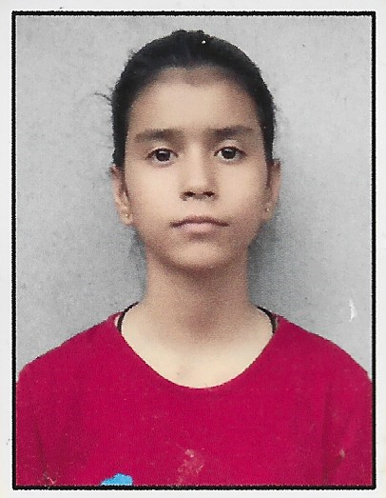Passport Size Ph oto

**(Higher Technical and Skill Development, Govt. of Jharkhand)**

# SHAVI RAMOTRA

B TECH. (HONS), COMPUTER SCIENCE AND ENGINEERING

**DOB:**-08 Sept 2004 **Roll. No**: - 2209047

**OBJECTIVE**

B. Tech Student in Computer Science and Engineering at BIT SINDRI seeking to hold a position at bureaucratic level and show rights ways to how to proceed as a guide.

**EDUCATIONAL QUALIFICATION:**

|  |  |  |  |  |  |
| --- | --- | --- | --- | --- | --- |
|  | **Name of Examination** | **Year of passing** | **Board/**  **University** | **Institution** | **Percentage/**  **CGPA** |
| **Graduation** | **B.TECH** | **2026** | **JUT** | **B.I.T SINDRI** | **NA** |
| **Senior Secondary(XII)** | **JKBOSE 12th EXAM** | **2022** | **JKBOSE** | **Govt. Girls Higher Secondary School, SAMBA.** | **84.6** |
| **Secondary**  **School(X)** | **JKBOSE 10th EXAM** | **2020** | **JKBOSE** | **Lord Krishna High School, SAMBA.** | **84.8** |

**ACADEMIC ACHIEVEMENTS:**

* Scored more than 80% in matriculation and in intermediate.

**CO-CURRICULAR ACTIVITIES:**

* NA

**TECHNICAL SKILLS:**

* C/C++,JAVA,MYSQL

**HOBBIES AND INTERESTS:**

* LEARN NEW THINGS.
* WEB DESIGNING.
* PLAYING ONLINE GAMES.

**PERSONAL INFORMATION:**

|  |  |  |
| --- | --- | --- |
| **Correspondence Address :-** | **RAKH AMB TALI , SAMBA**  **JAMMU AND KASHMIR.** | |
| **Permanent Address :-** | **RAKH AMB TALI , SAMBA**  **JAMMU AND KASHMIR.** | |
| **Email id :-** | **shaviramotra@gmail.com** | |
| **Phone/Mob No :-** | **9103173057** | |
| **Father’s Name | Occupation:-** | **MULKH RAJ** | **CIVIL DEFENCE** |
| **Mother’s Name | Occupation:-** | **RANI DEVI** | **HOUSE WIFE** |

**TRAINING/ INTERNSHIPS:**

|  |  |  |
| --- | --- | --- |
| **ORANIZATION** | **PERIOD** | **PROJECT TITLE** |
| CODSOFT | 4 WEEKS | WEB DEVELOPMENT PROJECT:  PORTFOLIO,LANDING PAGE WITH HTML,CSS,JAVASCRIPT |
|  |  |  |
|  |  |  |

*I hereby declare that all the above-mentioned information given by me is true and correct to the best of my knowledge and belief.*

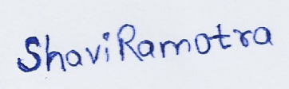

NAME: SHAVI RAMOTRA

*(Signature of student)*